**Booking system (60%)**

You need to implement the booking system class.

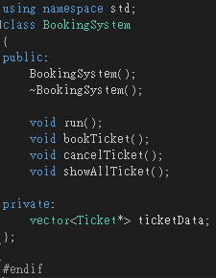 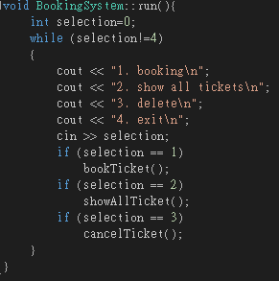

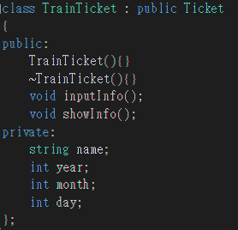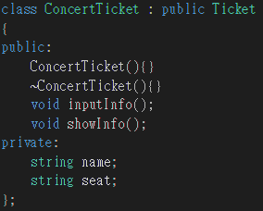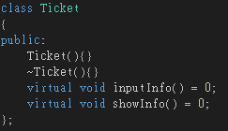

ConcertTicket and TrainTicket Inherit from the Ticket.

Use the concept of polymorphism to store both type of tickets in ticketData. This will make the work easier.

void bookTicket(); 20%

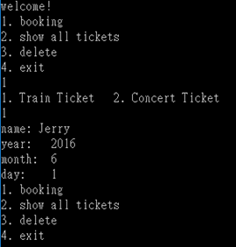 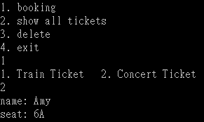

Input the Ticket Information and save them to ticketData.

void cancelTicket(); 20%

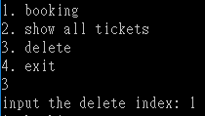 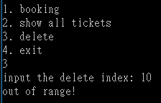

Input the index to delete the data in ticketData.

If the index is out of range, show some error message.

The deleted data will not be show by void showAllTicket().

Hint: use erase function.

// erase the 6th element

myvector.erase (myvector.begin()+5);

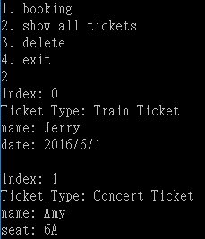

void showAllTicket(); 20%

Show the all the ticket’s information in ticketData. Show index first. The index is just the index of ticket in ticketData.